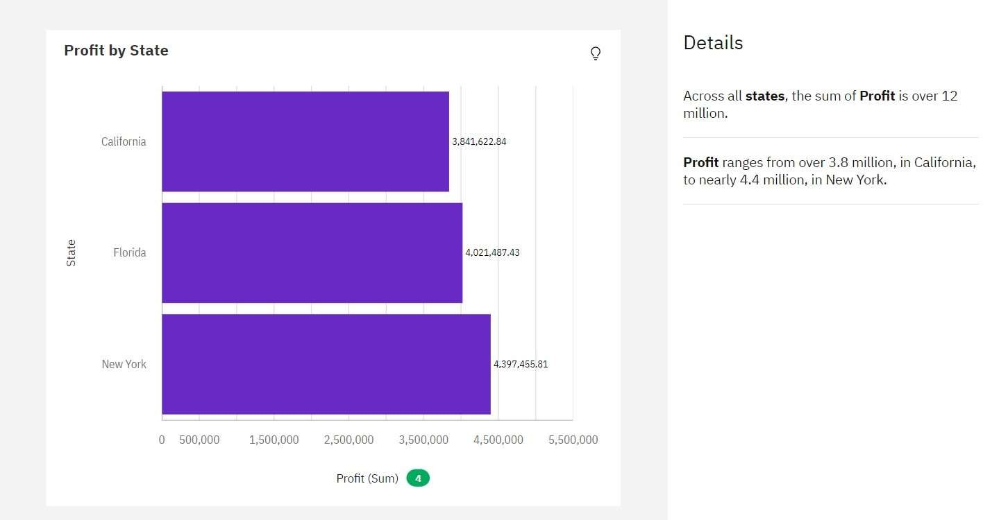

|  |  |
| --- | --- |
| Assignment Date | 19 September 2022 |
| Student Name | Bharath Kumar K |
| Student Roll Number | 731619104009 |
| Maximum Marks | 2 Marks |

